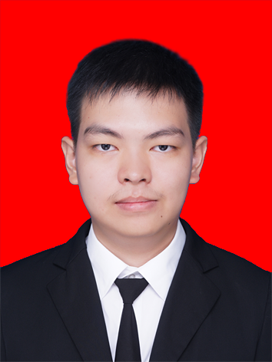
Eric Suwarno
Jalan Prof. T. Zulkarnaen no. 9
Medan 20154
Phone: (+62) 812 6946 2204
E-mail: 121402071.es@gmail.com

Education
University of Sumatera Utara, 2012 – 2017
Medan, North Sumatera
Degree: Sarjana Komputer (S.Kom.)
GPA: 3.55 of 4

Legal Experience
Laboratory Assistant October 2014 – January 2017
Information Technology Laboratory Group,
Faculty of Computer Science and Information Technology,
University of Sumatera Utara, Medan
I am instructing a practical lesson session to my junior classmates, with assistance of my lecturer. In addition, I am also assisting them to solve the difficulties when they are working with their final assignments and projects.

Special Skills
I have the ability to adapt with the requirements when working on a project. I have my own excitement when learning to code in new programming language. New programming language means new experience to me, and I like to work on it. Exploring new thing is one of my biggest happiness. Currently, I have ability to code in PHP and Python language, along with PHP web frameworks like CodeIgniter and Laravel. Also, I am currently learning languages such as Django and Golang. Internet-based application is my main interest. I am highly motivated to build something that can help anyone to do sort of works easier.

